Humogen  (somatropin (rDNA origin) for injection  Human Growth Hormone |  | Pharmaceutical Manufactures India
Taj Drug Products
 | 
Each Tablet contains:SOMATROPIN - INJECTION
Humogen® [somatropin [rDNA origin) for injectiontajdrug_Height-Increase
USES :>> Various brands of this medication are used for the treatment of one of the following medical conditions: growth failure, growth hormone deficiency, intestinal disorder (short bowel syndrome) or HIV-related weight loss or wasting
HOW TO USE: >> This medication is given by injection into a muscle or under the skin. The way you inject this medicine will depend on the brand that you are using. Check with your pharmacist to ensure that the way you are injecting your medicine is correct. It is important to change the location of the injection site to avoid problem areas under the skin. For best results, this medication must be used exactly as prescribed by your doctor. It is important to understand your therapy and to follow your doctor's instructions closely.
If this medicine is used for short bowel syndrome, consult your doctor if a special diet (high carbohydrate/lowfat) or the use of nutritional supplements may be helpful. If this medicine is used for weight loss/muscle wasting, it may take up to 2 weeks to notice the effects of the drug. Do not use more of this medication than prescribed or use it more often since the risk of side effects will be increased. Learn how to prepare, mix, and inject your medicine correctly. Be sure to ask your doctor or pharmacist any questions you may have and follow the instructions for mixing provided with the medication.
Do not shake while mixing the solution. Shaking makes the medication not work properly. Before using, check this product visually for particles or discoloration. If either is present, do not use the liquid. Needles and syringes are for one-time use only. Do not reuse. Throw away used needles, syringes, and medical supplies properly. Consult your pharmacist.
SIDE EFFECTS : >> Headache, nausea, vomiting, fatigue, muscle pain, or weakness may occur. If these symptoms continue or become bothersome, inform your doctor or pharmacist promptly. Tell your doctor immediately if any of these unlikely but serious side effects occur: development of a limp, joint/hip/knee pain, unusual increase in thirst or urination, swelling of hands, ankles or legs, rapid heartbeat.
Tell your doctor immediately if any of these highly unlikely but very serious side effects occur: change in the appearance or size of any mole, severe stomach pain, vision problems or changes, seizure. Rare (possibly fatal) lung/breathing problems may be caused by this medication in children with Prader-Willi syndrome. Those at higher risk include males, severely overweight children, or those with serious lung/breathing problems ( e.g., sleep apnea, lung infections, lung disease). Children should be checked for certain breathing problems (upper airway obstruction) before and during treatment. Heavy snoring or irregular breathing during sleep (sleep apnea) are signs of airway obstruction. Tell the doctor immediately if these signs occur. Also report any signs of lung infection, such as fever, persistent cough, or trouble breathing.

A serious allergic reaction to this drug in unlikely, but seek immediate medical attention if it occurs. Symptoms of a serious allergic reaction include: rash, itching, severe swelling, dizziness, trouble breathing. If you notice other effects not listed above, contact your doctor or pharmacist.
PRECAUTIONS :>> Before taking somatropin, tell your doctor or pharmacist if you are allergic to it; or if you have any other allergies. This medication should not be used if you have certain medical conditions. Before using this medicine, consult your doctor or pharmacist if you have: major surgery or trauma, severe breathing problems (acute respiratory failure), undergoing therapy for tumors (cancer), Prader-Willi syndrome (see Side Effects section above), normal growth has stopped (closed epiphyses). Before using this medication, tell your doctor or pharmacist your medical history, especially of: diabetes, thyroid problems, back problems (scoliosis).
When this medication is given to newborns, mix with sterile water for injection that does not contain a preservative. A preservative (benzyl alcohol) which may be found in the liquid used to mix this product can infrequently cause serious problems (sometimes death), if given by injection to an infant during the first months of life. The risk is greater with lower birth weight infants and is greater with increased amounts of benzyl alcohol. Symptoms include sudden gasping, low blood pressure, or a very slow heartbeat. Report these symptoms to the doctor immediately should they occur. Caution is advised when using in the elderly because elderly patients may be more sensitive to its effects.
Needle Instructions
Humogen® [somatropin (rDNA origin) for injection] is injected under the skin each day, usually at bedtime. This type of injection is simpler and less penetrating than injections that are given directly to the muscle or a vein.
Download the Injection Instructions to obtain your treatment guides to Humogen®.
How to Inject Humogen®
Before each injection, gather the tools and place them on a clean, flat surface and in an area that has good light. Wash hands with soap and water thoroughly before beginning. If someone else is administering the injection, make sure they put on a pair of disposable gloves.
IMPORTANT: >> Be sure all injection items are unopened prior to use. If you find an open needle or syringe packet, do not use it. Dispose of it in a sharps container. Needles and syringes should never be shared or reused.
Injecting Humogen® [somatropin (rDNA origin) for injection]
1. Remove the flip tops from the drug and diluent vials, and throw them away.
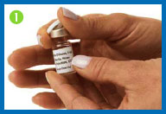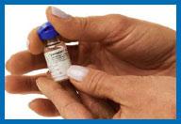
2. Clean both rubber stoppers with a fresh alcohol swab, then throw the swab away. Do not touch the vial tops with your hands or gloves after cleaning them. If you do, wipe the tops again with a fresh alcohol swab.
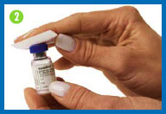
3. Prepare your needle.
Unwrap the syringe and the larger needle without touching the hub of the needle where it connects to the syringe. Remove the plastic tip protector from the syringe.
Keeping the needle cap, attach it securely to the syringe.
If you touch the hub of the needle or the bottom of the syringe, dispose of them in your sharps container and use new ones.
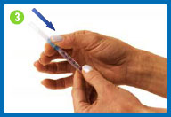
4. Prepare the syringe
Pull back on the syringe plunger until it reaches the 1cc/1ml point on the syringe barrel, or the volume indicated by your healthcare provider.
While holding the syringe in one hand, pull the needle cap straight off with the other hand. Set the needle cap aside for use later.
If the needle and the syringe come apart — and they have not touched anything — simply put them back together again. If the needle and/or syringe have touched anything, dispose of them in your sharps container, and start over again from Step 3.
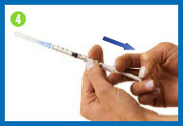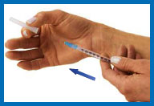
5. Fill syringe with diluent
Place the vial of diluent on your clean work surface.
Carefully insert the needle straight down through the center of the rubber stopper into the vial of diluent.
Gently inject all the air from the syringe into the vial by pushing down on the plunger. (The injected air will make it easier to withdraw the solution).
Without removing the needle, hold the plunger with one hand and turn the vial upside down. Pull back the syringe to make sure that the needle tip is below the diluent level in the vial.
Pull the plunger to allow the diluent to fill the barrel of the syringe to the appropriate level.
When you have the right amount of diluent in the syringe, remove the needle from the vial being careful not to touch the needle or allow it to touch any surface.
Throw the vial of diluent away.
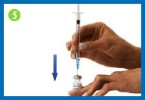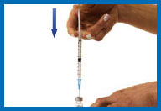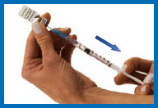
6. Prepare your Humogen® [somatropin (rDNA origin) for injection] for injection
Place the vial containing Humogen® powder on your work surface.
Insert the needle through the center of the rubber stopper into the Humogen® vial. Slowly and gently push the plunger, allowing the diluent to flow down the side of the vial. Do not squirt the diluent because this will make the solution foamy. If it becomes foamy, let it sit until the bubbles disappear and the liquid becomes clear.
Keeping the needle in the vial, gently swirl the vial until the powder is dissolved. Do not shake or turn the vial upside down.
Once the medication has been mixed, give yourself the injection as indicated in the instructions in the next steps. Reconstituted solution has to be used immediately. Any unused solution should be discarded. Do not inject Humogen® if the product is cloudy after reconstitution (in this case, contact your healthcare provider).
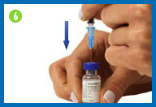
7. Fill the syringe with the solution
Turn the vial upside down making sure the tip of the needle is below the fluid level.
Pull back on the plunger and fill the syringe barrel with the solution.
Make sure that the tip of the needle remains in the solution while slowly backing the needle out of the vial to withdraw as much solution as possible.
Carefully remove the needle from the vial without touching the needle or allowing it to touch any surface.
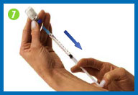
8. Change the needle
Before you give yourself the injection, you must replace the larger needle with the smaller needle.
Take the needle cap you set aside, place it on your work surface, and recap the needle with a scooping movement, as indicated in the photo. The cap should snap down on the needle. Do not touch the needle or allow it to touch any surface.
Once the cap is on the needle, gently twist the needle cap off of the syringe and place them in your sharps container.
Do not squirt any of the solution out of the syringe.
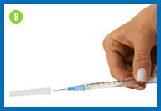 | 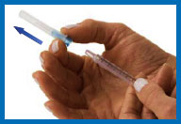

9. Put on the smaller needle
Unwrap the smaller needle and twist it onto the syringe, then carefully remove the needle cap.
Hold the syringe straight with the needle facing up.
To remove any air from the syringe barrel and the needle, gently tap the side of the syringe with your fingertips until all the bubbles float to the top of the syringe. Then gently push the plunger until a small drop of liquid appears on the tip of the needle.
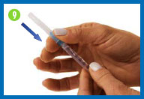 | 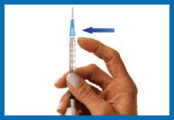

10. Pick an injection site
Find a place on your body where it will be easy for you to give yourself the injection. Recommended areas include the top of the thigh and either side of the navel. Make sure to change the location of your injection each day so that one area does not get injected too many times.
Before you inject, take an alcohol swab and carefully clean a four-inch square area around your injection site. Throw the swab away and let the skin dry.
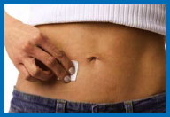
11. Inject Humogen® [somatropin (rDNA origin) for injection]
Hold the syringe in one hand and remove the cap from the needle.
With your other hand, gently pinch a three-inch fold of skin.
Point the needle downward, with the slanted, cutting edge of the needle facing up, about an inch away from the area you plan to inject.
Push the needle tip into the pinched skin as far as it will go. Hold the syringe steady and let go of the skin.
Push the plunger down slowly and gently as far as it will go.
When the syringe is empty, pull the needle straight out of the skin and put it in your sharps container.
If you accidentally stick yourself with the needle after your injection, clean the stuck area with soap and water to prevent infection. Place a 2"x 2" gauze patch over the area and apply gentle pressure to stop any bleeding.
If someone else gets pricked by the needle after the injection, let the area bleed freely. Then wash the area thoroughly with soap and water, and call their doctor immediately to explain what happened.

12. Clean up after injecting
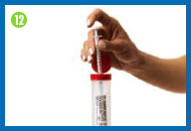
Immediately discard the injection needle, needle cap, syringe, used gauze patches, and used gloves in your sharps container.
Presentation
Somatropin Injection Each 1 ml Injection
Note : This product information is intended only for residents of the India. Taj Pharmaceuticals Limited, medicines help to treat and prevent a range of conditions—from the most common to the most challenging—for people around the world.
Information for Health Care Professionals
*** Please consult local Prescribing Information for any product before use. This website is an international information resource for healthcare professionals with an interest in disease management. This website is not intended to replace the advice of a qualified healthcare professional. Above brand is a trademark of the Taj group of companies (Taj Pharmaceuticals Limited).



